Why are ethnic minorities politically underrepresented?

In this essay, I argue that ethnic minorities are not politically underrepresented because of a lack of electoral participation. Instead, I argue that ethnic minorities are politically underrepresented mainly because of party incentives. First, I show that ethnic minorities are politically underrepresented in terms of descriptive representation and in their substantive representation, and that these do not necessarily go together. Then, I argue that ethnic minorities participate in politics almost as much as majority groups. Finally, I argue that the underrepresentation instead stems from party incentives and supply-side factors.

Underrepresented

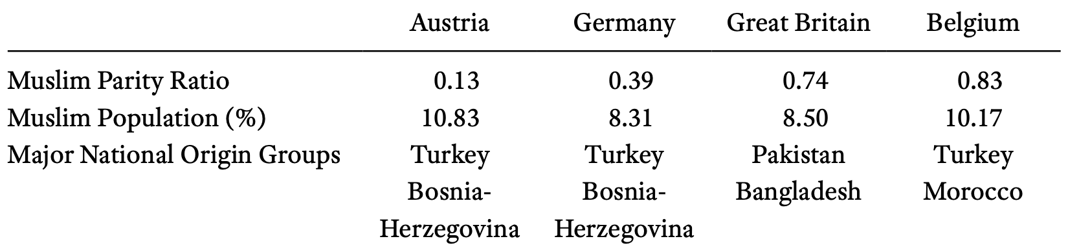
Ethnic minorities are underrepresented in politics. Both with regards to descriptive representation, so how many members of parliament are part of an ethnic minority, and in their policy preferences. In the United Kingdom, the amount of minority MPs has always been lower than the share of the electorate (Heath 2013, ch. 1). Throughout Europe, Muslims are underrepresented, as shown in Table 1. This shows the Muslim Parity Ratio, the percentage of Muslim local politicians divided by the percentage of Muslims in the population, which is in all the four countries shown below 1.
Table 1: The percentage of Muslim local politicians divided by the percentage of Muslims in the population (Dancygier 2017, 4).

Furthermore, minority policy preferences are also underrepresented. Although they largely agree with majority groups what the important issues are, the state of the economy, unemployment, and immigration, they differ from the majority in their emphasis on equality of opportunity. And despite the rising number of politicians with ethnic minority backgrounds, parties are doing and promising little to address, for instance, inequalities in the labour market (Heath 2013, chs 4–5). Wardt et al. (2024) have tried to explain this paradox by arguing that MPs from ethnic minority backgrounds are a reputational shield, allowing the party to move more to the right, the median voter, on immigration issues. That way, the party still signals tolerance and diversity to not alienate liberal supporters who dislike the new anti-immigration sentiment. Thus, an increase in the descriptive representation of ethnic minorities may actually decrease their substantive, programmatic representation: ethnic minorities are usually more in favour of immigration, because they usually did it themselves. Acquarone and Di Landro (2025) furthermore show that the politicians with ethnic minority backgrounds barely differ from the party line in their ideology. They find that non-white MPs lean modestly to the left, but that this effect shrinks sharply within parties and that non-white MPs do not cause parties to shift left, once one controls for the ideological baseline. Therefore, the discrete inclusion of ethnic minorities does not necessarily lead to a substantive representation of minorities, it might in fact signal the opposite.

Electoral participation

One reason why minorities are underrepresented in politics could be that they do not participate as much as majority groups. If they do not vote as much, it would make sense that they are underrepresented. However, there is no evidence of political disengagement or abstention among minorities. In the United Kingdom, there is only about a 10-point gap in voter registration, which is largely explained by socioeconomic position. And among registered voters, turnout rates of minorities are very similar to white Britons (Heath 2013, ch. 7; Sanders et al. 2014). In fact, ethnic minorities are more likely to agree that it is every citizen’s duty to vote: 91 percent of minorities agree while only 78 percent of white British people agree (Heath 2013, ch. 3). In other ways, their electoral participation is also very similar to that of the majority, such as through demonstrations or boycotts (Heath 2013, ch. 9). Once they are enfranchised, Muslims and other immigrant groups participate at similar or higher levels in politics throughout Europe (Dancygier 2017, ch. 1) .

Who do people vote for?

Supply-side Factors

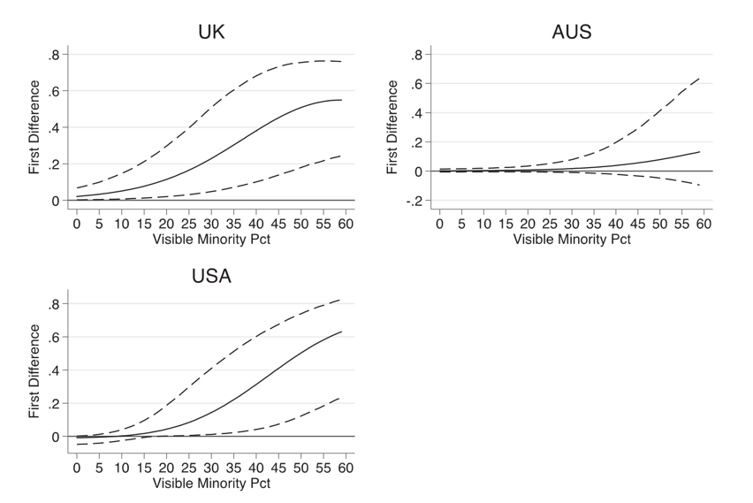
In the inclusion of ethnic minorities, parties face electoral trade-offs. Minorities already overwhelmingly identify with parties on the left. A great majority of minority voters votes for Labour in the UK because of their history of representing them, more so than people from working class backgrounds. As a result, Labour can take these minority voters for granted, prioritizing other voters instead (Heath 2013, chs 5–6). In the 2010 election, for instance, Labour’s party manifesto did not mention more action to increase equality of opportunity. And although the Liberal Democrats did mention this, ethnic minorities sticked with Labour because of their strong historic party identification.
Figure 1: The difference in the probability of nominating an ethnic minority candidate between centre-left and centre-right parties in the UK, Australia, and the US (Farrer and Zingher 2018, 479). The X-axis is the percentage of visible minority population in a district; the Y-axis shows the marginal change in the likelihood of nominating a minority candidate.

Also true for independence candidates in the recent election, probably mainly with Palestinian stuff.

There are, however, cases where ethnic minority votes do become relevant. Farrer and Zingher (2018) show that parties start nominating minority candidates once a district has a sufficiently large minority population. In the United States, moving from a 0 percent to a 60 percent black population in a district, raises the probability of a Black Democratic candidate to around 99 percent. This is especially true for centre-left parties who have the most to gain from this. As Figure 1 shows, centre-left parties are much more responsive to an increase in a minority population in a district. However, as Dancygier (2017) argues, parties do face a dilemma when they nominate minority candidates. When left-wing parties want to gain votes from especially Muslims (that group is the one he focuses on), they can choose to recruit religious and conservative community leaders who might be able to mobilize minority voters but can clash with the progressive values of the parties. This, however, might alienate cosmopolitan urban voters who dislike these traditional values. As a result, parties might limit themselves to symbolic inclusion, with minority candidates who follow the party line and not really substantively represent minorities. This explains why it is difficult for left-wing parties to represent minorities as they face a dilemma between the more conservative minorities and the liberal, urban voters.

A lot of research shows that there are structural barriers to minority candidacy. Party elites are less likely to recruit ethnic minorities to the party. Not only because they fear the backlash from native voters, but also because these, usually white elites, might favour people “like themselves” and doubt minority candidates’ abilities to connect with established bases. Lajevardi et al. (2024) also show that minorities feel less welcome in the party in Sweden and the United States. They argue that the perception that politics is an unwelcoming, majority dominated environment discourages entry.

In conclusion, ethnic minorities are not politically underrepresented because they fail to participate in politics, but because the political system limits their inclusion. Minority citizens throughout Europe are as engaged as the majority. Yet their presence in elected office remains low, and their policy concerns, particularly around equality and discrimination, receive little attention. This disconnect arises from how parties make strategic choices about recruitment and representation. Party leaders prioritise electoral safety, fearing backlash from majority voters or tension within their own coalitions, and therefore often restrict minority inclusion to symbolic gestures or unwinnable seats. Structural barriers and informal biases within party organisations further deter minority candidates and reinforce perceptions that politics is an unwelcoming environment. As a result, ethnic minorities’ underrepresentation is not driven by apathy or disengagement but by party incentives, institutional gatekeeping, and the strategic constraints that shape who gains access to political power.

Bibliography
Acquarone, Iris E., and Gonzalo Di Landro. 2025. ‘Historically Marginalized Groups and Ideological Representation in Legislatures’. Legislative Studies Quarterly 50(2): 250–57. doi:10.1111/lsq.12466.
Dancygier, Rafaela M. 2017. Dilemmas of Inclusion: Muslims in European Politics. Princeton, NJ: Princeton University Press,. doi:10.1515/9781400888108.
Farrer, Benjamin David, and Joshua N. Zingher. 2018. ‘Explaining the Nomination of Ethnic Minority Candidates: How Party-Level Factors and District-Level Factors Interact’. Journal of Elections, Public Opinion and Parties 28(4): 467–87. doi:10.1080/17457289.2018.1425694.
Heath, A. F. 2013. The Political Integration of Ethnic Minorities in Britain. 1st ed. Oxford: University Press.
Lajevardi, Nazita, Moa Mårtensson, and Kåre Vernby. 2024. ‘Do Minorities Feel Welcome in Politics? A Cross-Cultural Study of the United States and Sweden’. British Journal of Political Science 54(4): 1435–44. doi:10.1017/S0007123424000073.
Sanders, David, Anthony Heath, Stephen Fisher, and Maria Sobolewska. 2014. ‘The Calculus of Ethnic Minority Voting in Britain’. Political Studies 62(2): 230–51. doi:10.1111/1467-9248.12040.
Wardt, Marc van de, Maria Sobolewska, and Patrick English. 2024. ‘Ethnic Minority MPs as Reputational Shields? How Western European Political Parties Respond to Public Opinion Shifts on Immigration Policy’. European Political Science Review 16(4): 503–20. doi:10.1017/S175577392400002X.

Notes

How do we define ethnicity:
- Religion? Where you are from? Self-identification with cultur, history
- Difference between nation? Multi-ethnic nations?
- Difference between race? Just skin-colour? Self-identification, or even more important identification of the outgroup
- Race mainly important in America, less important in Europe
- Depending on socialization what is more important

How does it cross-cut with other cleavages:

How does ethnicity cause voting:
- Self-interest
- Socio-tropic voting
- Socialization leading to individual
- Is it all minorities, or your own minorities. Interminority differences.
- Can we reduce it to class
- Also about discrimination
- Usually morel left-wing, but more traditional
- Discrimination is more salient than traditional stuff
- Being a white pro-minorities person, that is different for immigrant who are just pro-ethnic minorities
- What is more important, substantive or descriptive? Probably substantive
- Are they more right-wing? Home countries small welfare state? Or is it because immigrants are more self-selective, by virtue of coming all the way to Europe you are more individualistic.

American ethnic and racial groups:
- Republicans were always the party of abolition with Lincoln, but the democrats were the party of the southern slave owners.
- Interwar period: the new deal which makes the labour market more equal, so they benefit from pro-distribution policies under the democrats. So its not about race but about class. It convinced roughly half of black voters to switch to democrats.
- So the democrats become a coalition of the blacks and the southern racists. And with the civil rights movement makes it so that the democratic party become the party for black americans.
- The republicans try to get the freed southern voters, racist southern voters join the republicans. Conscious strategy.
- Also true for other minorities, but is changing a bit because the minorities are more conservative: especially the Hispanics.
- Linked faith, sociotropic voters among afro-americans also drives the fact that
- White immigrants had this also, were working class so for the democrats. But over-time they move towards the republican party. Probably because they get assimilated, they are no longer a minority, they are becoming white americans and vote the same way as the white americans. And the Hispanics are following a similar trend.
- Hispanics: Cubans and venezualans are much more republicans than Puerto Ricans or Mexicans. Probably because the Cubans and venezualans are much richer which is why they leave their country which becomes a socialist dictatorship and so that is why they leave.
- Asian-americans: they are less talked about. They are very diverse, many different countries in Asia. Traditionally portrayed as the model minority, they are the “good ones”, they are highly educated entrepreneurial etc. The Muslim divide with mamdani, which makes it more similar to Europe.
- Why is race more important in the US rather than class? Slave-owners were white and so the rich people were white. And it was a top-down strategy to divide politics along racial lines to also get the poor white peole.
- Do the democrats use race? So the democrats put together poor minorities with rich white voters and the republicans the opposite.

Voting for minorities vs white?
- People are quite racist.

Difference between

Urban density among immigrants
Successful immmigrants: Jewish and indians

